Cylindrical Pivot:-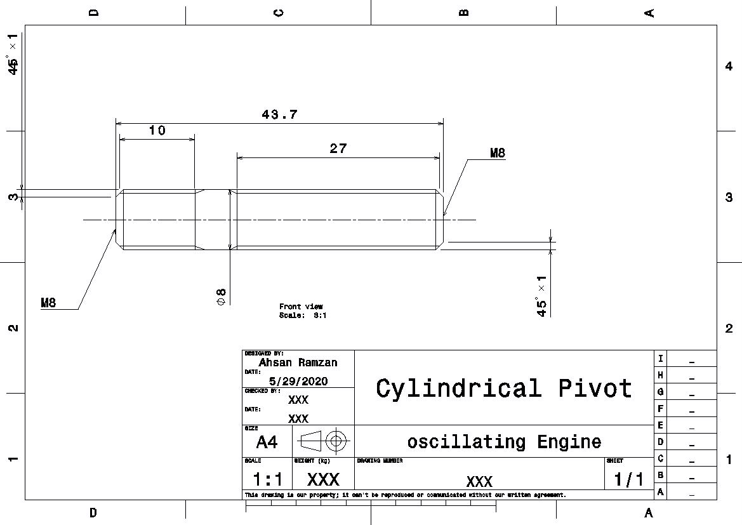
This is the engineering drawing of cylindrical pivot of the oscillating engine. The cylindrical pivot has four chamfers with 1mm and 45 degree. The length of the cylindrical pivot is 43.7mm.The cylindrical pivot is threaded on both side.
A rod of brass in cylindrical shape given to the group with a lab sheet for instruction and essential calculation. In the first part of the roughing the right part of the pivot done by doing a chamfer of 1mm at 45 degree. During this process the speed of the spindle set at 3000rpm.
The G96 command is used when we require a constant surface speed or cutting speed. This speed indicates the distance that the tool moves along the components surface per minute.
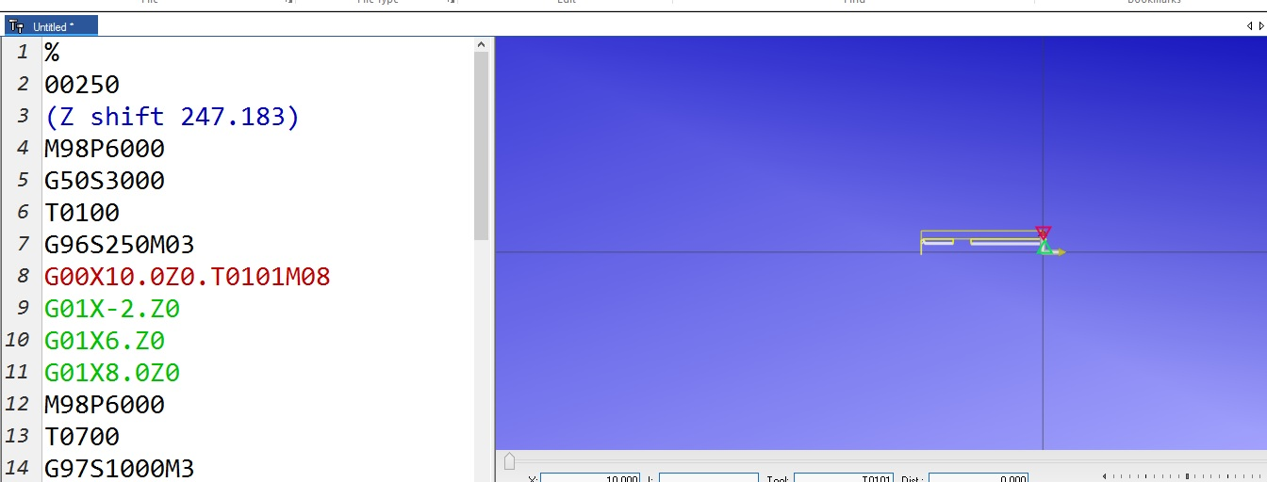
G50 can be used to limit the maximum spindle speed. The control will not allow the spindle to exceed the S address value specified in the G50 command. This is used in constant surface feed mode (G96). This G code will also limit the secondary spindle on DS-Series machines.
The spindle speed on these G codes process of material was maintain as follows:
The speed of 3000rpm with G 50 for the maximum spindle speed limit whereas the a speed of 250 rpm was used during the G96 for a constant cutting speed of tool.
The G97 code is use to control the RPM of the spindle directly constant spindle speed command .This would be used for many reasons including Centre line work such as drilling and tapping. As in our case the code used id given below
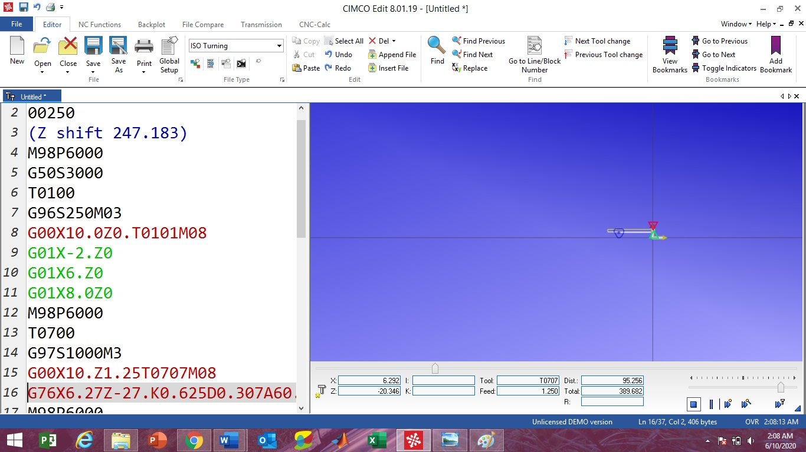
G97 S1000 M3

Again the G97code was used for a control speed of the tool and also this all the measurements are related to left side tapping of the cylindrical pivot with a length of 10mm as shown in the engineering drawing of the part.
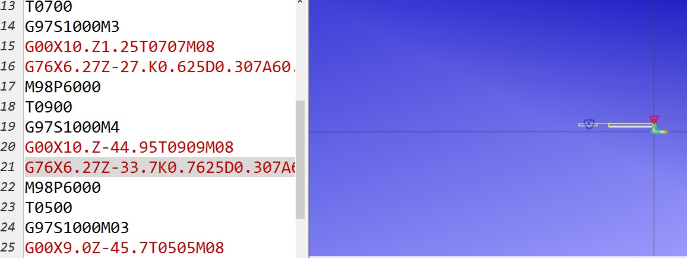
This time the spindle speed of the tool set at 1000 rpm with G97 code for tapping.
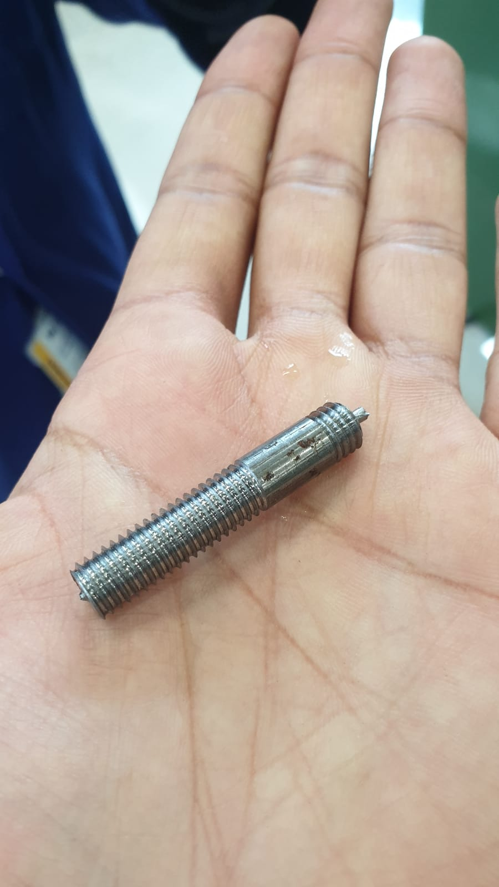
The selected code in red color in above screen shot clearly shows the tapping to other side of the cylindrical pivot.
Final Product:-

